**A**

**SEMINAR REPORT ON**

**“Hydroponics Enviornment control system with Predictive Analysis”**

SUBMITTED TO THE SAVITRIBAI PHULE PUNE UNIVERSITY IN THE PARTIAL FULFILLMENT OF THE REQUIREMENTS FOR THE AWARD OF THE DEGREE

OF

**THIRD YEAR OF ENGINEERING**

**(COMPUTER ENGINEERING)**

SUBMITTED BY

**Mr. Pranav Nandkishor Gavali**  **Exam No.**

**UNDER THE GUIDANCE OF**

**Prof/Dr. K.Avhad**



**DEPARTMENT OF COMPUTER ENGINEERING**

**STES’S SINHGAD ACADEMY OF ENGINEERING**

**KONDHWA, PUNE 411048**

**UNIVERSITY OF PUNE**

**2020-21**



**DEPARTMENT OF COMPUTER ENGINEERING**

**STES’S SINHGAD ACADEMY OF ENGINEERING**

**KONDHWA, PUNE 411048**

**CERTIFICATE**

This is to certify that the Seminar report entitle

**“Hydroponics Enviornment control system with Predictive Analysis”**

Submitted by

Mr. Pranav Nandkishor Gavali Exam No:

is a bonafide work carried out by him/her under the supervision of **Prof. K.Avhad** and it is submitted towards the fulfillment of the requirement of Savitribai Phule Pune University, for the award of the degree of Third year of Engineering (Computer Engineering).

**Prof . K.Avhad**  **Prof. B. B. Gite**

Guide Head,

Department of Computer Engineering Department of Computer Engineering

**Dr. K.P.Patil**

Principal,

Sinhgad Academy of Engineering, Pune – 48

Place : Pune

**Date : 20 / 5 / 2021**

**ACKNOWLEDGEMENT**

I would like to thank **Prof. K. Avhad**  for helping/Guiding me out in selecting the topic and contents, giving valuable suggestions in preparation of Seminar report and presentation.

I am grateful to **Prof. B. B. Gite**, Head of Computer Department, for providing healthy environment and facilities in the department. He allowed us to raise our concern and worked to solve it by extending his co-operation time to time.

Goal makes us to do work. Vision is more important than goal which makes us to do work in the best way to make work equally the best. Thanks to Principal, **Dr. K.P.Patil** for his support and vision.

Consistent achievement requires boost on consistent interval basis. Management has given full support and boosted us to be consistent and achieve the target. Thanks to management for their support.

Thanks to all the colleagues for their extended support and valuable guidance. I would like to be grateful to all my friends for their consistent support, help and guidance.

**Pranav Nandkishor Gavali**

**ABSTRACT**

Hydroponic systems, such as the deep flow technique nutrient film technique or aeroponic systems, are essential tools in plant factories. For adequate management of water and nutrients in the hydroponic system, the electrical conductivity (EC), pH, dissolved oxygen, and temperature should be measured. Because ion concentrations in the nutrient solutions change with time, resulting in a nutrient imbalance in closed hydroponic systems, real-time measurements of all nutrients are required, but such measurements are not available due to technical problems. Instead, EC-based hydroponic systems are used in commercial farms. Periodical analysis of nutrient solutions and adjustment of nutrient ratios can improve the nutrient balance. As an advanced method, ion-selective electrodes and artificial neural networks can be efficient tools for estimating the concentration of each ion. For stable crop production, disinfection systems using filters, heat, ozone, and ultraviolet radiation are required in hydroponic systems.

**CONTENTS**

|  |  |
| --- | --- |
| **ACKNOWLEDGEMENT** | **I** |
| **ABSTRACT**  **INDEX** | **II**  **III** |
| **LIST OF FIGURES** | **IV** |
| **LIST OF ABBREVIATIONS** | **V** |

**INDEX**

|  |  |  |  |
| --- | --- | --- | --- |
| **CHAPTER NO.** |  | **NAME OF CHAPTER** | **PAGE NO.** |
|  |  |  |  |
| **1** |  | **INTRODUCTION** |  |
|  | 1.1 | SEMINAR IDEA | 1 |
|  | 1.2 | MOTIVATION OF THE SEMINAR | 3 |
|  | 1.3 | LITERATURE SURVEY | 5 |
|  |  |  |  |
| **2** |  | **SCOPE** |  |
|  | 2.1 | PROBLEM STATEMENT | 7 |
|  | 2.2 | GOALS AND OBJECTIVES | 7 |
|  | 2.3 | STATEMENT OF SCOPE | 9 |
|  |  |  |  |
|  |  |  |  |
| 3 |  | **PROCESS OF HYDROPONICS** |  |
|  | 3.1 | EXISTING TYPES & TECHNOLOGIES USED IN HYDROPONICS | 13 |
|  | 3.2 | ADVANTAGES OF HYDROPONICS | 16 |
|  | 3.3 | DISADVANTAGES OF HYDROPONICS | 16 |
|  |  |  |  |
|  | 3.4 | FUTURE SCOPE | 18 |
|  |  |  |  |
| 4 |  | CONCLUSIONS | 20 |
|  |  |  |  |
| 5 |  | REFERENCES | 21 |

**LIST OF FIGURES**

|  |  |  |
| --- | --- | --- |
|  |  |  |
| 1 | Render of a Hydroponics Lab (CG) | 1 |
| 2 | A Project implementing the same by farm beats | 5 |
| 3 | MIT’s Open Agriculture Initiative make use of ML & AI to grow crops of the future. | 6 |
| 4 | Block Diagram of a Simple IoT based Smart Hydroponics System | 8 |
| 5 | Concept of implementing ML, AI & AR | 11 |
| 6 | Block Diagram of a System’s Process of implementing Machine Learning | 12 |
|  |  |  |

**LIST OF ABBREVATIONS**

|  |  |
| --- | --- |
|  |  |
| AI | Artificial Intelligence |
| pH | Power of Hydrogen / Potential of Hydrogen |
| IoT | Internet of Things |
| ML | Machine Learning |
| AR | Augmented Reality |
| MS | Microsoft |
| AWS | Amazon Web Service |
| DIY | Do it yourself |
| MIT | Massachusetts Institute of Technology |
|  |  |

1. **INTRODUCTION**

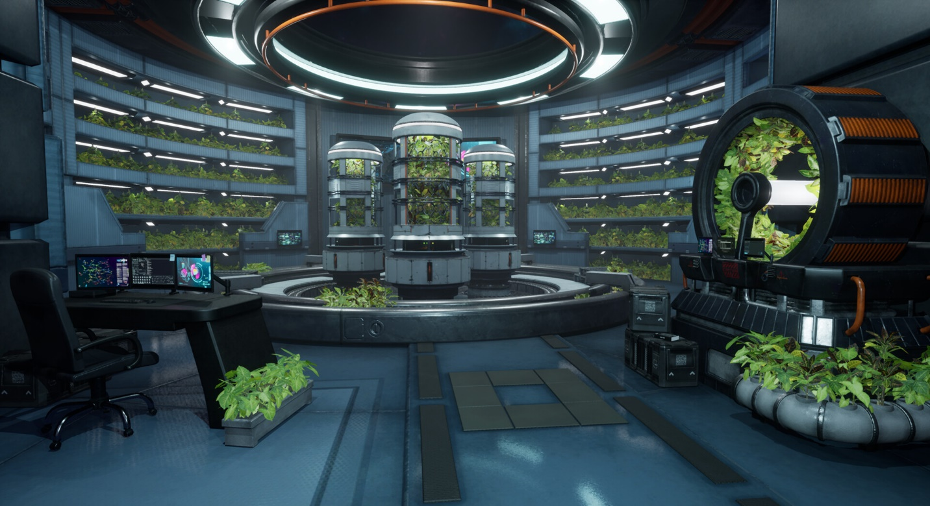

Fig. Render of a Possible Hydroponics Lab

Hydroponics is a method of growing crops without soil. Plants are grown in rows or on trellises, just like in a traditional garden, but they have their roots in water rather than in dirt. Most of us confuse soil with nutrients. In fact, soil provides structure, not the actual food itself, for plant roots. The food comes from other materials mixed in the soil, such as compost, broken-down plant waste or fertilizers. Plants grown hydroponically can actually grow faster and healthier than plants in soil because they don't have to fight soil borne diseases; in addition, all the food and water they need are given directly to their roots around the clock.

Growing plants hydroponically doesn't have to be done on a large scale, and it's easier than you might think. Now there are kits, DIY systems and even fully automated growing tables, all designed for home gardeners.

Hydroponics is very simple -- in many ways, it's simpler than growing plants in soil. Plants need food, water and air. When you break it down to those three things, it becomes simple to give plants only what they need. Hydroponics is the science of growing plants without soil. The plants thrive on the nutrient solution alone; the medium merely acts as a support for the plants and their root systems.

### ****From Traditional Hydroponics to AI-powered Smart Hydroponics:****

Technology doesn’t let innovation rest and always pushes for advancement. The same goes for Hydroponics, which has gone a step further to evolve into what’s already being referred to as ‘Smart Hydroponics’.

For the uninitiated, Hydroponics is a technique for growing a smart farm within a greenhouse. Here, a ‘smart farm’ refers to a soilless, vertical setup that can house a thousand plants and more. A Hydroponics farm may just be our best bet for churning out chemical-free produce in less than half the space of actual farmland.

It’s typically preferable to cultivate salad greens like Lettuce, Parsley, Radish, Pakchoi, etc., in a Hydroponics greenhouse.

**MOTIVATION OF THE SEMINAR**

The first reason to do things this way is undoubtedly water efficiency. In places where water is scarce, which is more and more place every year these days, applying water directly to the exposed roots of plants saves vast amounts of water over the old method of spraying it across a field and just letting it trickle down through the dirt.

As places like Israel and California suffer through increasingly harsh droughts, this will become a major consideration. Along with using less water overall, modern hydroponic techniques allow for greater cost efficiency in other areas. One of these is [*the use of fertilizer*](https://www.greenwaybiotech.com/collections/hydroponics-nutrients).

It's still really inefficient, though, since most of the fertilizer doesn't get taken up by the crops, leaving it to be washed out into the nearest watershed and then into the lake or rivers, where it can cause unfortunate algal blooms. In the ocean, these fertilizer-caused blooms can reach epic size and poison the water with a so-called "red tide."

Hydroponic facilities use far less fertilizer, and they apply it directly to the roots of the plants. Whatever amount the plants don't take up simply drips off the roots and is recycled for another go. These chemicals also tend to accumulate in the food chain, so that a poison that kills grasshoppers gets eaten by a bird, which then eats another grasshopper, and then another, until the pesticides of dozens of dead grasshoppers have built up in the bird's body.

That bird may then go on to lay eggs with unusually thin shells or nonviable embryos. Hydroponics solves that problem, and the related problem of artificial herbicides, by mostly skipping them altogether.

In the controlled environment of a hydroponics bay, pests are either not present at all, or they are a minor problem that can be handled by more natural approaches, such as ladybugs and preying mantises.

Assuming the harvesting crew remembers to give hydroponic celery a good shake to get these bugs off before they go on the truck, this can reduce or entirely eliminate the risk of pest control measures making it to the produce section of the grocery store.

Another major advantage of hydroponics is the impressive flexibility that the controlled environment gives growers.

The reason artificial chemicals are needed at all is because plants ultimately must grow out in the open, [where aphids and plant rusts can get at them](https://www.greenwaybiotech.com/blogs/gardening-articles/5-harmful-garden-insects-and-how-to-eliminate-them), where it might not rain enough or too much, and [where soil conditions might not be perfect](https://www.greenwaybiotech.com/blogs/gardening-articles/how-to-improve-soil-health-with-amendments) for growing the particular crop that's needed.

**Hydroponics solves all of these issues in a stroke.**

When plants are grown indoors, the length of the day -- which varies with latitude and season -- becomes largely irrelevant, which allows sensitive tropical crops like sugar to be grown in Sahara Desert, if desired.

Those plants can also be maximized for yield, without regard to drought and pest resistance. Hydroponics is not the ideal choice for every garden, of course. The equipment tends to be a bit pricey to start, and special facilities are currently needed to grow any sizable crop on a commercial scale.

With those limitations in mind, however, the massive cost efficiency, pesticide reduction, and close control these techniques allow make hydroponics an excellent candidate for the next agricultural revolution.

**LITERATURE SURVEY**

As discussed about different hydroponic systems. In a project where Nutrient film technique is been implemented. Parameters such as temperature and humidity are controlled by Arduino ATMega2560. System with IoT devices have hardware characteristics identical with less power, less processing power, less memory, even the communication resources are called as resources constrained devices. It is one of the advantages as well as disadvantage in development IoT technology system.

As read in the [this paper](https://ieeexplore.ieee.org/abstract/document/8229470)*(cited at references)*, Where farmers were able to increase the crop yield to up to 70% by implementing machine learning and using it to control proper-required environmental conditions.

In another scenario, A team implemented a deep learning neural network to perform a similar role of control, although the quantification of improvements here were not sufficient to claim that the control method would have been an improvement over a traditionally managed hydroponic setup, as the comparison is made between a soil control, not a hydroponic control with no automated environmental management. Fig : A Project implementing the same by farm beats

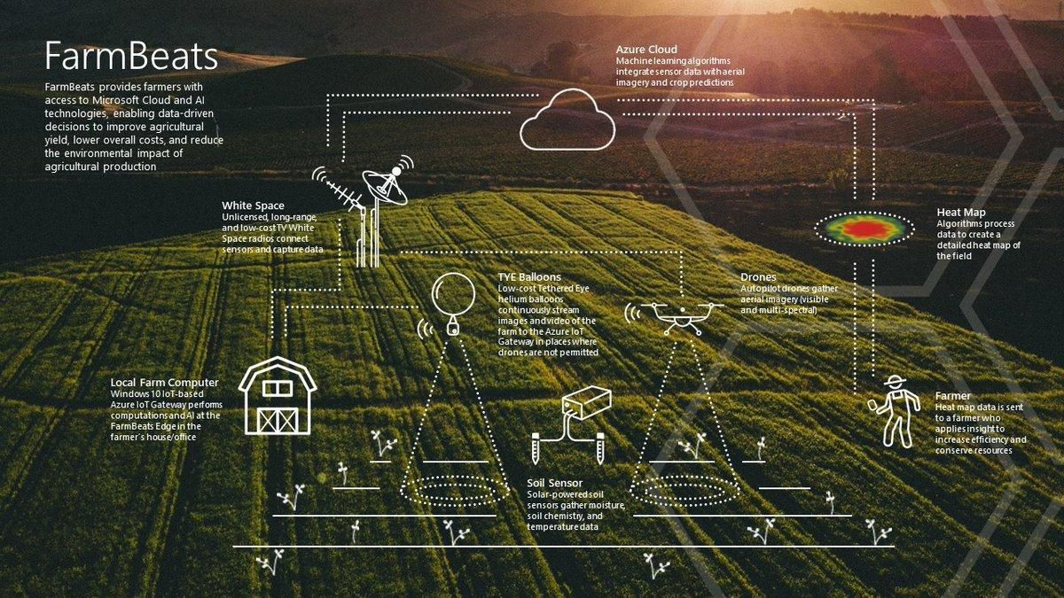

[Another](https://ieeexplore.ieee.org/abstract/document/8519997) Paper*(cited at references)* uses a simple IoT sensor control system and a multivariate regression approach in order to control the environment in a hydroponic greenhouse, this system was created with the aim to be cheap and usable in developing countries.

Research Laboratory based in MIT (Massachusetts Institute of Technology) say’s :

“Machine Learning can reveal optimal growing conditions to maximize taste and other features”

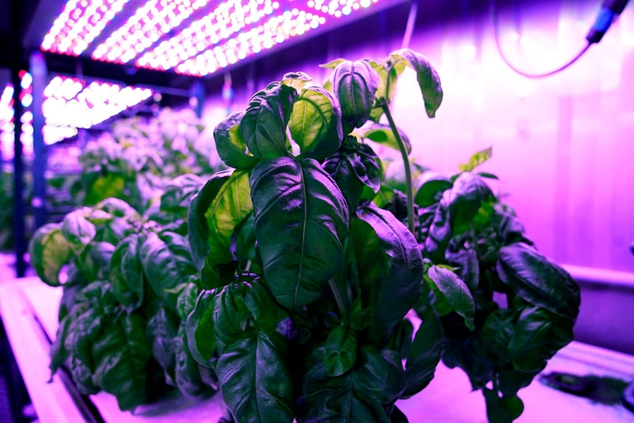

**Fig :** Researchers in MIT’s Open Agriculture Initiative grow basil under controlled environmental conditions to study how taste and other features are affected.

“There is a big problem right now in the agricultural space in terms of lack of publicly available data, lack of standards in data collection, and lack of data sharing,” Harper says. “So while machine learning and artificial intelligence and advanced algorithm design have moved so fast, the collection of well-tagged, meaningful agricultural data is way behind. Our tools being open-source, hopefully they will get spread faster and create the ability to do networked science together.”

**SCOPE**

**GOALS AND OBJECTIVES**

Hydroponic crops are dynamic systems, with plants continuously affecting their environment and demanding control actions in order to keep conditions constant. For example plants will tend to transpire water and absorb carbon dioxide during their light cycle, so in order to keep humidity and carbon dioxide concentrations constant you might need to turn on humidifiers, dehumidifiers, carbon dioxide generators, etc. Knowing what action needs to be taken is not trivial and naive control implementations – like turning on humidifiers, AC systems, etc when some thresholds are reached – can cause problems where sensors fight each other (for example a sensor trying to increase ambient humidity and another trying to raise temperature) or even fail to trigger.

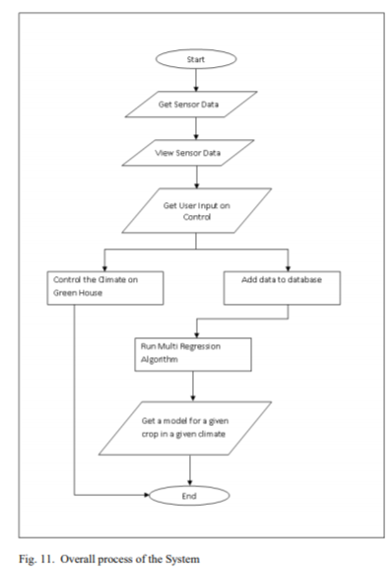

Fig. Process of achieving the said Goal

In order to provide better control, researchers have created systems that rely on machine learning – systems that can learn from examples – in order to learn what control actions are needed and execute them in order to provide ideal control to a hydroponic setup. A machine learning system will be able to anticipate things like the lag between turning an AC unit on and the temperature decreasing, so it will be able to be both more efficient and more accurate in the way it controls your environment. This use of automated control guided by machine learning is also known as “smart hydroponics”.

**SCOPE OF IMPLEMENTING ML & AI FOR HYDROPONICS**

For example you can read [this paper](https://ieeexplore.ieee.org/abstract/document/8229470)*(cited at references)* where growers were able to increase the yield of a crop by 66% just by ensuring they could maintain proper environmental conditions the entire time using machine learning. In this case the researchers use a probabilistic method where the system determines the probability of an action – like triggering a sensor – will cause a desired effect. As data is accumulated the system basically executes whichever action has the highest probability to lead to the desired outcome.

There are other papers on the subject. In [this one](https://www.sciencedirect.com/science/article/pii/S0168169918311839)*(cited at references)* a deep learning neural network is used to perform a similar control role, although the quantification of improvements in this paper is not sufficient to claim that the control method would have been an improvement over a traditionally managed hydroponic setup, as the comparison is made between a soil control, not a hydroponic control with no automated environmental management.

[Another](https://ieeexplore.ieee.org/abstract/document/8519997) Paper*(cited at references)* uses a simple IoT sensor control system and a multivariate regression approach in order to control the environment in a hydroponic greenhouse, this system was created with the aim to be cheap and usable in developing countries.

Although there are now several different demonstrations of this being done in the literature there still does not seem to be a commercially mature technology to carry out this task and the implementations seem to still be tailor made to each particular situation. However the modeling techniques used are not exceedingly complex and even modest commercial growers could – nowadays – afford to setup something of this nature.

Fig. Concept of implementing ML, AI & AR

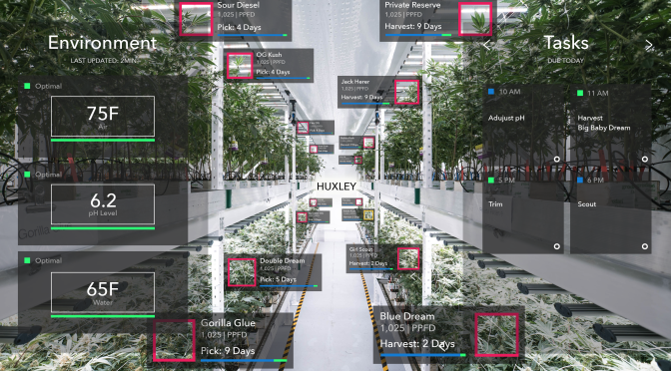

With a computer, some Arduino’s, raspberry pi computers, sensors and time and effort a grower could definitely setup a very nice, machine learning based control system to benefit from the above described technologies.

1. To Achieve a complete Smart Hydroponics System
2. Reduce human effort by leveraging Technologies
3. Exponentially increase the Quality of Food and Nutrient rich Crops

**II. PROCESS OF IMPLEMENTING ML & AI**

**Example.**

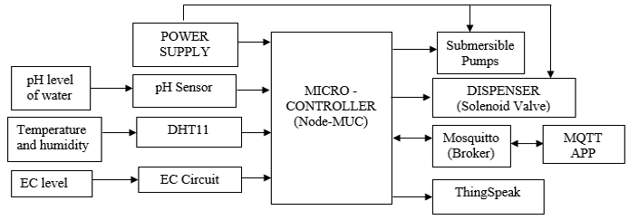

Fig : Block Diagram of a Traditional IoT based Smart Hydroponics System

In the above block diagram (fig 1), we can see that three sensors are used namely pH sensor for pH level of water, DHT11 for temperature(\*c) and humidity(gm/m3) & Circuit to measure the conductivity of the water level. For communication Single bus data format is used and synchronization between DHT11 and MCU sensor. One communication process is takes about 4ms. Data consists of integral and decimal parts. A complete data transmission is of 40bit , and the sensor sends higher data bit first. Data format: 8bit integral humidity data + 8bit decimal humidity data + 8bit integral temperature data + 8bit decimal temperature data + 8bit check sum (Error bits). If the data transmission is right, the check-sum should be the last 8bit of "8bit integral humidity data + 8bit decimal humidity data + 8bit integral temperature data + 8-bit decimal temperature data". All these sensors are interfaced to an open source Node-MCU (ESP12) which will act as a microcontroller. This microcontroller is also interfaced with 3.3V power supply. Valves, Pumps, & Dispenser are being controlled by the Node-MCU for efficient working of system. All this information is being send to a mobile app (MQTT). The controlling of whole system is automated using NodeMCU (Controller) and IoT. However, there is manual controlling provision through Mobile App with the help of LAN connection in case of absence of internet connection. The dispenser is used to mix the nutrients with the water. The water containing nutrients is passed to the pipes with help of submersible pumps.

The water which is not absorbed by the crops is reused by adding nutrients according to the reading from sensor and again passed to the pipes.

### ****What can AI technology do for Hydroponic farming?****

AgriTech’s new entrant ‘Hydroponics’ seems to have expanded its possibilities even further. But it looks like AI’s tryst with the latter will take [smart farming](https://analyticsindiamag.com/smart-farming-iot-agriculture/) to even greater heights. AI is already doing a lot to further the possibilities of Hydroponics:

* **Seed profiling** – Germination is key to growing plants in a Hydroponics farm. Germination is typically carried out on special soil-like Coco peat (coconut husk). Once the seeds germinate and reach a desirable height, they are re-potted into a vertical soilless setup. In this stage, AI can be delegated to perform seed profiling to determine the best germination rate for different plants.
* **Plant nutrients** – The saplings in a hydroponics farm need to be carefully supplied with nutrients in measured quantities. AI can be assigned this task of measuring the optimal nutrient quantity based on the crop profile.
* **AI Greenhouses**: It is critical to have appropriate and desirable conditions within the greenhouse. Maintaining constant temperature inside the greenhouse looks like a task AI can do successfully. AI can automate the greenhouse temperature, which can then subsequently be regulated on a software solution. Depending on the crops being grown, smart farmers can equip themselves to modulate the greenhouse environment.

**III**.**EXISTING TYPES & TECHNOLOGIES USED IN HYDROPONICS**

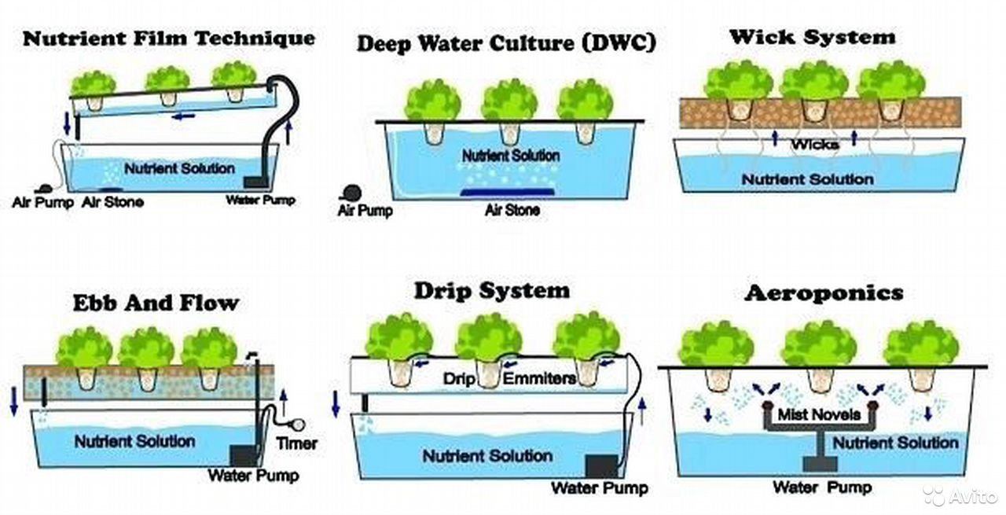

### ****From Traditional Hydroponics to AI-powered Smart Hydroponics:****

Technology doesn’t let innovation rest and always pushes for advancement. The same goes for Hydroponics, which has gone a step further to evolve into what’s already being referred to as ‘Smart Hydroponics’.

#### **How AI facilitates Smart Hydroponics:**

AI-driven’ Smart Hydroponics’ can determine optimum growth for a plant through a combination of hardware setup and a software tool that can recreate its growth trajectory. Insights are generated from data obtained by sensors in the hardware.

The sensing hardware is divided into three categories, each of which is strategically placed within the hydroponics farm. They sit near the plant roots and collect data about the crop’s such as

1. Vitals
2. pH levels
3. Electrical conductivity levels
4. Nutrient supply
5. Light Density
6. Light Intensity
7. Temperature
8. Humidity Levels, etc

A visual camera can also be placed which checks the growing plants for colouration and feeds the data to the AI software. On the other hand, insights about the precise nature and needs of the products are generated through machine learning and potentially could be processed and acted upon by an Artificial Intelligence system.

#### **Automation in Vertical Farming:**

The AI software system works like the brain behind the entire Hydroponic farm. It can choose between different types of LED lighting and modulate light intensity. It can even turn on a suitable [irrigation](https://analyticsindiamag.com/precision-farming-control-irrigation-improve-fertilization-strategies-corn-crops/) system. It drives end-to-end automation so that fewer manual tasks are delegated.

### ****The status of AI in Hydroponics in India:****

Currently, AI in Hydroponics in India may be in a fledging state. Although a few successful Hydroponics startups have managed to raise capital and innovate with AI, there is still a lack of general awareness about the potential of AI-driven Hydroponics farming.

AI in Hydroponics in India is currently restricted to a number of young ‘agripreneurs’ who are attempting to [transform agriculture in India](https://analyticsindiamag.com/5-tech-startups-in-india-working-to-weed-out-middlemen-from-agriculture-supply-chain/)*(Link leads to an article by analyticsmag)* into a niche market by innovating through AI.

These startups have grown to a commercial level where the farmer uses AI-driven automation systems and farm management software to track and control the Hydroponics farm remotely. That being said, Hydroponics farms are trending not just in India but the world over.

While the Indian market is expected to achieve a compound annual growth rate of 13.53% by 2027, the global market, on the other hand, is set to touch a whopping $17.9 billion by 2026. Globally, high-tech hydroponics farming is adding more and more startups and urban farms with each passing day. There is also great interest among big-league investors. Globally, AI is shaping the future of Hydroponics.

#### **Companies working towards bringing AI to Hydroponics:**

In India, noteworthy companies that are bringing or rather have already brought AI to Hydroponics include[Agro2o](https://www.agro2o.com/), a Delhi-based startup that has prototyped a ‘smart hydroponic garden’ equipped with IoT and AI growing algorithms. Agro2o’s founder took AI’s help to tackle traditional Hydroponics challenges, like the need to maintain consistent pH levels and electrical conductivity.

Another noteworthy company is [Agritech](https://www.agritechgroup.com/" \t "_blank)which worked on challenges like harsh weather. They deployed smart precision technology that combines AI with 5G and machine learning to measure humidity and determine water measurement.

**IV. ADVANTAGES**

**When Compared To Traditional Soil-Grown Crop Production, Hydroponics Has the Following Advantages:**

* Up to 90% more efficient use of water.
* Production increases 3 to 10 times in the same amount of space.
* Many crops can be produced twice as fast in a well managed hydroponic system.
* Decreasing the time between harvest and consumption increases the nutritional value of the end product.
* Indoor farming in a climate controlled environment means farms can exist in places where weather and soil conditions are not favorable for traditional food production.
* No chemical weed or pest control products are needed when operating a hydroponic system.

**V. DISADVANTAGES**

* Putting together a hydroponic system isn’t cheap.
* Constant monitoring is required.
* Hydroponic systems are vulnerable to power outages.  In the event of a power outage that outlasts your generators you will be manually watering your garden.
* Micro-organisms that are water-based can creep in rather easily.
* Growing a hydroponic garden demands technical expertise.
* Production is limited compared to field conditions
* If a disease appears, all plants in the system will be affected.
* Without soil to serve as a buffer if the system fails plant death will occur rapidly.

**VII. FUTURE SCOPE & ENHANCEMENTS**

**How Future will Take on Hydroponic Farming Concepts in India ?**

A general conception among the Indian farming community is that staple crops and vegetables cannot be grown in absence of good soil, good water and plenty of sunlight. This conception is true to an extent, but certainly, the farming trends across the globe are changing, and India is standing on the brink of adopting this valuable change.

Today new farming practices are being adopted, which clearly show healthy plants need water, nutrients and high-quality seeds. There is absolutely no requirement of soil. The term Hydroponic Farming refers to this type of farming. Growing plants with hydroponics technology require no sunlight, but blue, red and yellow spectrum.

By all means, hydroponic farming in India is in its nascent stage. As a matter of fact, farming practices in India are largely traditional. The current market for this type of hydroponic farming is only limited to metropolitan and cosmopolitan towns with a mere mention of tier-1 cities. Hydroponic Farming is under the innovation and creative technologies are being adopted in India by the progressively thinking farmers. The extent of green units operational in India are only designed for growing micro greens. The plan to grow full blown staple crops like rice, wheat, bajra etc., is a dream.

Growing lettuce and other vegetables in hydroponic units is expensive for the reason that their growth cannot be taken to the surplus levels in these units. The earning potential from hydroponic farming units is high, but the costs of establishing such units are even higher.

**Scope of Smart Hydroponic Farming in New India.**

Population size of India is indiscriminately increasing, and this is one of the major reasons why size of arable land is reducing in availability. Since arable land area is continuously reducing, it is becoming difficult to produce staple crops for rapidly growing population. With hydroponic farming method, the arable space problem in India will be solved in the future. More cultivars of staple crops can be grown, and consumption of soil and water will be reduced, or just not required.

How it would appear, when crops will be grown in visible light spectrum, and there will be fresh food available for everyone on the land. This could be a start of new green revolution; which millennia’s out here are going to witness.

Another significant benefit of Hydroponic farming evolution in India will alleviate the burden on poor people and the environment in which we breathe and survive. How this will happen? Since hydroponic farms requires less of space and water, and growth is alarmingly quick than the traditional farming, fruits and vegetables will be grown quickly. With surplus food available for everyone, there will not be fight for the hunger. In this innovative process water is also saved, which means more water is available for various other purposes.

Finally, the hydroponic farming will reduce pests and weed production on alarming levels. Therefore, the use of pesticides, insecticides and weedicides will be reduced. There will nit be any land pollution. For now, this technological revolution is a fringe movement, and much of exploration is underway.

**CONCLUSION**

Hydroponics is the effective technology for the places of the world having scarcity of infertile and arable land for cultivation of crops. Fresh products can also be harvested through hydroponics throughout the year as it is not like traditional cultivation practices.

Growing plants in a nutrient solution offers a number of advantages such as Applying plant nutrients in fertilizers directly to the roots without the problems associated with the soil’s composition or the fertilizer’s inability to infiltrate into the root system; No need for heavy machinery to prepare beds for seeds or planting; Weeds and diseases can be controlled without spraying chemicals and no irrigation systems have to be installed for fertigation; Erosion of the soil by repeated cultivation is avoided.

Additionally technologies like Machine Learning, Artificial Intelligence, Deep Learning, etc can help to boost this sector and help deploy it for millennials. As observed, we can conclude that using such technologies can help us increase crop yield over 70% and reduce the cost significantly ‘over-time’ as well.

**REFERENCES**

[1] Somchoke Ruengittinun, Sitthidech Phongsamsuan, Phasawut Sureeratanakorn ”Applied Internet of Thing for Smart Hydroponic Farming Ecosystem(HFE)” 2017 10th International Conference on Ubi-media Computing and Workshops.

[2] Chavan Akshay A, Pawar Abhijeet S, Wagh Pratik V, Prof. Lalita Wani ”IoT Based Hydroponic System” International Journal of Innovative Research in Computer and Communication Engineering Vol. 5, Issue 4, April 2017

[3] Y. P. Jayasuriya, C. S. Elvitigala, K. Wamakulasooriya and B. Sudantha, "Low Cost and IoT Based Greenhouse with Climate Monitoring and Controlling System for Tropical Countries," 2018 International Conference on System Science and Engineering (ICSSE), 2018, pp. 1-6, doi: 10.1109/ICSSE.2018.8519997.

[4] Manav Mehra, Sameer Saxena, Suresh Sankaranarayanan, Rijo Jackson Tom, M. Veeramanikandan,

IoT based hydroponics system using Deep Neural Networks,

Computers and Electronics in Agriculture,

Volume 155,2018,Pages 473-486,ISSN 0168-1699, (https://doi.org/10.1016/j.compag.2018.10.015.)

*Keywords: IoT; Hydroponics; Tensor flow; Automated agriculture*

[5] M. I. Alipio, A. E. M. Dela Cruz, J. D. A. Doria and R. M. S. Fruto, "A smart hydroponics farming system using exact inference in Bayesian network," 2017 IEEE 6th Global Conference on Consumer Electronics (GCCE), 2017, pp. 1-5, doi: 10.1109/GCCE.2017.8229470. [11] K.P. Ferentinos; L.D. Albright “Fault Detection and Diagnosis in Deeptrough Hydroponics using Intelligent Computational Tools” Biosystems Engineering 84 (1), 13–30

[6] PothierMonitoring of Hydroponics System using IoT Technology Nivesh Patil, Shubham Patil, Animesh Uttekar, A. R. Suryawanshi, International Research Journal of Engineering and Technology (IRJET) Volume: 07 Issue: 06 | June 2020

[7] Plant Farming ‘An Indoor Vertical Farming System for Efficient Quality Food Production’ Second Edition, 2020, by Toyoki Kozai, Genhua Niu, Michiko Takagaki